Interstate Data

One difference of Victoria and NSW compared to SA is that they have hydro power and other renewable energy sources such as biomass generators. However, these sources are considered as dispatchable. Therefore, the assumption made is that these forms of renewable sources will be used in local supply and demand matching rather than a source that can be used to export interstate. Another assumption made that any excess generation can be exported to SA. Due to network constraints and the time at which excess generation occurs, this may not be physically possible. However, since the scope of this project is SA, it is assumed that the interconnectors can be used to import excess interstate generation.

The following sections explore the generation and demand traces of Victoria and NSW, respectively. The aim of these sections is to provide an overview of the types of renewable energy generation available and the scale of these grids with respect to SA’s.

# Interstate Generation

As was the case previously, NSW and Victoria solar and wind capacities were verified by comparing the total capacities to AEMO’s generation workbook. For both NSW and Victoria, there seemed to be a discrepancy between the numbers reported in the REZ worksheet and the summary worksheet. Despite countless effort to balance these REZ numbers with the data in the assumptions workbook, there were still slight differences. Therefore, the amount in the South West NSW solar REZ was decreased by 642.65MW and the amount in Central North Victoria REZ was decreased by 75MW.

There were also some issues where the retirement date specified in AEMO’s assumptions workbook did not line up with the REZ table. Therefore, the retirement dates of Hillston and Coleambally Solar Farm were extended to 2051 to ensure the data to match. There was also some difference around some of the later years, where the total capacity calculated in our model was approximately 300MW less than AEMO’s. Despite countless effort, the error could not be found and so no change was made. Although this error could not be fixed, it should not affect the results as it is more conservative.

The final note was that for offshore wind, fixed platforms are used as their numbers are more conservative. With the aforementioned issues addressed, the results of the generation traces are presented.

Depicted in Figure 1 and Figure 2 are the forecasted amounts of installed renewable energy capacity in NSW and Victoria, respectively. Note that these figures only include intermittent renewable energy sources and therefore, hydro and biomass are not included. The split between installed solar and wind in NSW is approximately equal for most of the forecast period whereas there is a significantly larger amount of installed wind capacity compared to solar in Victoria. Furthermore, AEMO forecasts that there will be development in Victoria’s offshore REZs, with there predicted to be 9GW of offshore wind from FY2040.

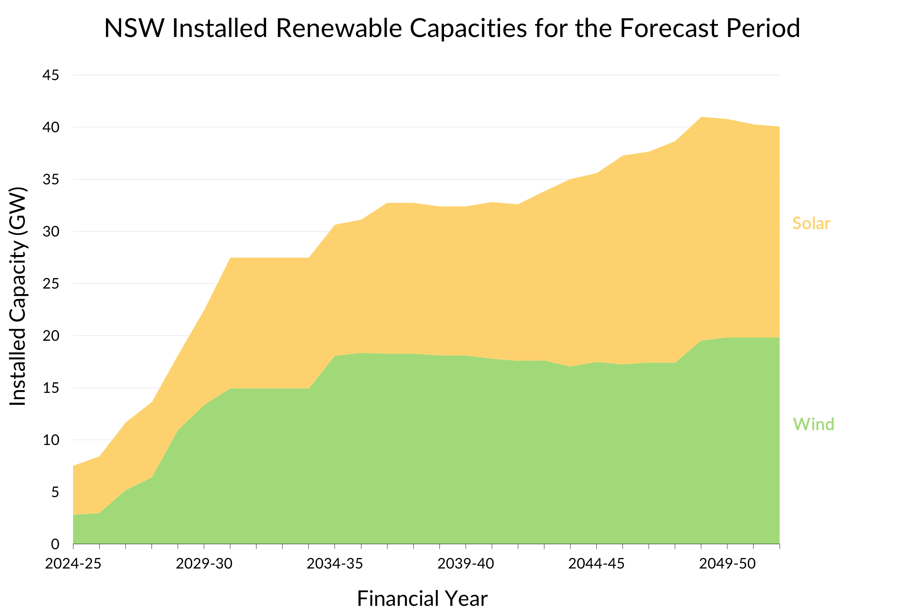

**Figure 1:** Installed renewable energy capacities in NSW over the forecast period.

**Figure 2:** Installed renewable energy capacities in Victoria over the forecast period.

The installed renewable energy capacities of NSW and Victoria are compared to SA’s in Figure 3 below. Compared to Victoria and NSW, the amount of installed renewable capacity is relatively small in SA. Although the scale of each installed capacities is different between each state, the trend of installed renewable capacities is quite similar. A hypothesis for this type of behaviour is due to the optimisation model used by AEMO that looks are the NEM as a whole which could result in similar renewable energy uptake trends.

**Figure 3:** Comparison of installed renewable energy capacities in SA, Victoria, and NSW over the forecast period.

# Interstate Demand

The annual operational demand in SA, Victoria, and NSW is shown in Figure 4. Currently, the demand in NSW exceeds SA but approximately six times and in Victoria, almost four times. Out of the three states, SA is set the experience the largest relative change in demand, doubling by FY2050. The demand is forecasted to increase significantly in Victoria throughout the 2030s before tapering out whereas the demand is forecasted to steadily grow throughout the forecast period in NSW.

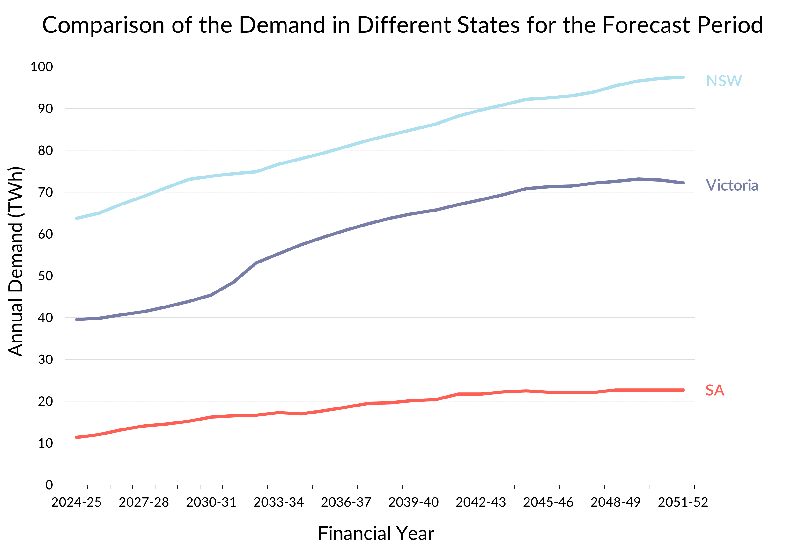

**Figure 4:** Comparison of annual operational demand between SA, Victoria, and NSW.